CURRICULUM VITAE
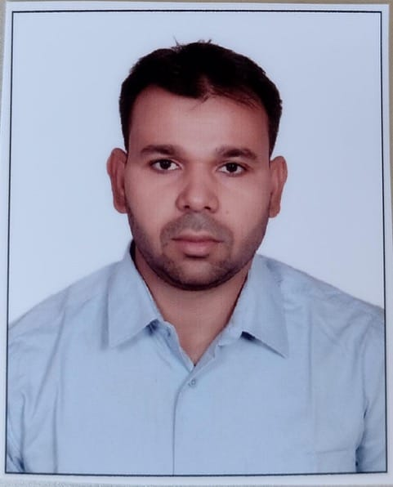

Dharmendra Yadav
Assistant Professor
Department of Geography
Shri Mahanth Ramashray Das Post Graduate College, Bhurkura, Ghazipur
Mobile Number- 7309378716
Email Id- emailmedy@gmail.com

Academic Profile

Degree/ courses | Subject | Board/University | Year of passing | Percentage
M.A. | Geography | BHU Varanasi | 2016 | 63
B.A. | Geography (hons), TTM, French | BHU Varanasi | 2013 | 71.8
Intermediate | Hindi, English, Math, Physics, Chemistry | U.P. Board | 2010 | 64.8
High School | Hindi, English, Physical Science, Life Science, Math, Geography, History | West Bengal Board | 2007 | 73.8

- Qualified UGC-NET/JRF in 2017
Teaching Experience
More than three years, since 11/07/2022, of teaching experience of subject of Geography (Under Graduate and Post Graduate level) in the College of Shri Mahanth Ramashray Das Post Graduate College, Bhurkura, Ghazipur.
Conferences/Seminars
Topic of paper presentation/Participation | Name of Seminars | Joining Date
Environment and Agricultural Sustainability in India: Issues and Prospects | 46th IIG Meet and International Conference; Dynamic Earth, Fragile Environment and Path to Climate Resilient Societies | 25-27 October 2025
Hindu Sanskriti me Paryavaran Samanjasya | National Seminar on Hinduism and Humanism | 24-25 December 2023
Ajadi ki Virasat aur Satat Vikas ka Paridrishya | National Seminar on Heritage of Independence: Continuity and Obstacles | 16-17 December 2022

Orientation/Refresher
Type (s) | Sponsored By | Remark
Orientation (FIP) | UGC Human Resource Development Centre, Banaras Hindu University, Varanasi-221005 | Completed successfully during 27 October to 9 November 2023

Personal Details
Name- Dharmendra Yadav
Father’s name- Ram Kishun Yadav
Date of Birth : 15th June, 1992
Sex : Male
Marital Status : Married
Nationality : Indian
Language known : Hindi, English
Permanent address : Village- Bahadurpur
Post-Zamania
Dist.- Ghazipur (UP)
Pin code- 232329
Contact Number : +91-7309378716
Declaration: I hereby declare that all the information given by me in this resume is true to the best of my knowledge.
Dharmendra Yadav

